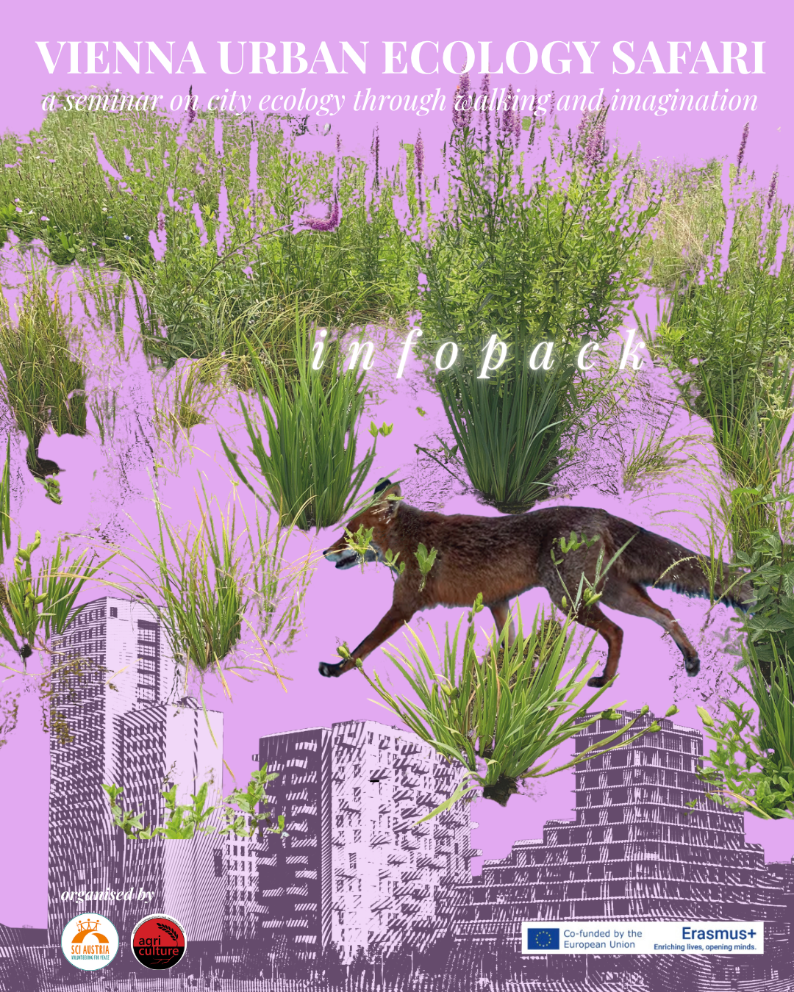

VIENNA URBAN ECOLOGY SAFARI
a seminar on city ecology through walking and imagination
7-14 JULY 2026

KEY DETAILS
- Duration: 7-14 July 2026
- Commitment: We’ll have a full 6 days, plus the late afternoon/evening of the 7th and the morning of the 14nd of July for preparing yourself and leaving the venue. So we recommend:
  - to arrive by the afternoon July 7.
  - to have 6 full working days from the 8th until the 13th of July 2026 for the training
  - to depart on the 14th of July 2026
- Location: Vienna, Austria
- Contact info: coordination@sciaustria.org

Learning Objectives

We will learn to understand
- how cities function as ecological systems shaped by relationships between people, infrastructure, water, soil, plants, animals, food, and public space
- how urban ecology is connected to climate adaptation, biodiversity, environmental justice, mobility, and everyday life
- how different parts of a city can be “read” as learning environments full of visible and invisible ecological processes
- how walking, observation, and place-based learning can become powerful tools for non-formal education

We will learn how to
- design and facilitate an urban ecology walk
- observe and interpret a neighbourhood through an ecological lens
- use mapping to explore relations between people, nature, infrastructure, and power
- create learning activities based on senses, curiosity, and direct experience
- turn public space into an educational setting
- connect urban ecology with youth work, community work, art, activism, and local initiatives
- translate local observations into workshops, reflection sessions, and educational tools

You will gain practical tools such as
- urban safari and walking-based facilitation methods
- sensory and observation exercises
- place-based reflection tools
- collective mapping techniques
- ideas for adapting these methods to their own communities, organisations, and target groups

By the end of the project, you will
- have a stronger understanding of urban ecology in practice
- feel more confident using the city itself as a learning space
- have tested concrete non-formal education methods
- leave with ideas, inspiration, and transferable tools for future activities in their own context

Your profile
We are looking for 20 motivated participants from Europe and beyond (preferably aged 22+) interested in exploring the city as a living ecosystem with critical and curious eyes and in using urban ecology as a tool for learning, community engagement and social change.
We welcome participants from diverse professional and personal backgrounds, especially:
- Youth workers and youth leaders active in environmental education, community work, or eager to integrate sustainability and place-based learning into their practice.
- Educators and teachers interested in outdoor learning, non-formal education, and creative ways of connecting people with the urban environment.
- NGO staff and community organisers working on ecology, climate, food, public space, inclusion, participation, or local development.
- Artists and cultural practitioners who explore relationships between people, place, ecology, and the more-than-human world.
- Gardeners, foragers, growers, and food practitioners interested in urban food systems, biodiversity, community gardens, and ecological ways of producing and sharing food.
- Activists, facilitators, and changemakers who want to develop new methods to read, experience, and teach the city through an ecological lens.
No advanced academic background is required. The course is open to both experienced practitioners and motivated learners who are curious, reflective, and willing to explore Vienna through walking, observation, exchange, and experimentation.
Priority: We strongly encourage applications from people living in urban areas, as well as individuals facing social and/or economic obstacles.

The team
Johannes Wiener, a gardener by training, works at the intersection of social ecology, architecture, art, and theory, and has experience in social work, agriculture, and arborism. He works with land, communities, and ideas, currently focusing on micro-climates, both on an ecological and socio-cultural level, and on rural-urban interfaces.
Gianmichele Tuozzo is a project designer, fundraiser and educator working on socio-ecological regeneration, environmental education and local development. With a background in philosophy, economics and international project management, he designs European projects and participatory learning experiences that connect sustainability, youth work, culture and rural transformation. In 2023, he co-founded Mòvesi APS, an NGO based in Southern Italy working on socio-cultural regeneration of depopulating rural areas.

Travelling to Vienna

Please plan to arrive on Tuesday, 7th July, during the day. The training will run for six full days, from 8th to 13th July, and requires your full participation. Departure is at 10:00 am on Tuesday, 14th July, after breakfast. Check-in will be available from 15:00. Upon arrival, you’ll have access to the kitchen facilities and all other amenities.

To support your preparations, we’ve compiled essential travel and logistics information below. Please review it carefully and start arranging your journey as early as possible.

- How much can my travels cost?
Conditions for Erasmus+ countries organisations
Compensation for travel costs: The project will cover the actual costs of bus/train/flight up to a maximum indicated below (distance calculated from the place of residence to Vienna on the Distance Calculator | Erasmus+):

Travel distance | Green travel | Non-Green travel
10 – 99 km | 56 EUR | 28 EUR
100 – 499 km | 285 EUR | 211 EUR
500 – 1999 km | 417 EUR | 309 EUR
2000 – 2999 km | 535 EUR | 395 EUR
3000 – 3999 km | 785 EUR | 580 EUR
4000 – 7999 km | 1188 EUR | 1188 EUR
8000 km or more | 1735 EUR | 1735 EUR

- What if I want to stay extra days or arrive a few days before?
You are allowed to arrive some days earlier and leave some days after the meeting, with a total of 5 days to distribute before and after the event, as you please.
Please note that accommodation for days beyond the meeting is not covered or booked by the project.

- Some tips for finding alternative transport to Vienna
Please try to avoid flying. We encourage you not to take the plane, even if it takes longer and requires extra effort. Planes are massively responsible for the climate crisis, and through our projects, we would like to contribute to a more sustainable planet, not to a less sustainable one.

AND PLEASE NOTICE THAT IT IS NOT ALLOWED TO USE MORE THAN ONE FLIGHT TO TRAVEL TO VIENNA.

- Compare the emissions that your journey emits by train, car or plane
- Read more about your ecological footprint here: http://footprint.wwf.org.uk
- Read more about the environmental impact of flying on Wikipedia

Some means of transport that we would suggest to reach Vienna are:

Train  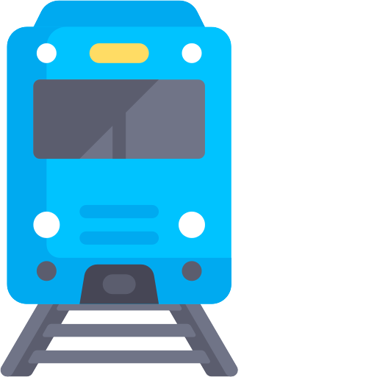 | You can easily reach Vienna by train from many destinations. You can find train schedules and tickets on the website of the Austrian Railways: https://www.oebb.at/en/  Check also the website of the German railways, because they might have cheap tickets for European destinations (“Sparschiene”) too: http://www.bahn.de  Alternatively, you can look up schedules and tickets on the app “Omio” or at Rail Europe: https://www.raileurope-world.com/
Bus  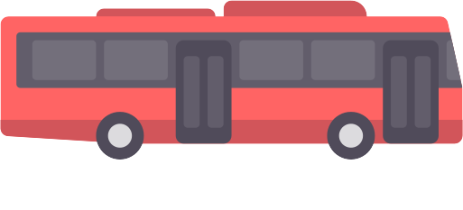 | Flixbus (http://www.flixbus.com) is an international bus company with connections across Europe, including many to Vienna. There are other companies with international connections, such as Eurolines (https://eurolines.com/).
Carpooling   | The website Blablacar (https://www.blablacar.com) offers options to share a car with someone from one place to another. You split the driving costs with the driver – please make sure to get an invoice from the website.
Bike, hitchhike  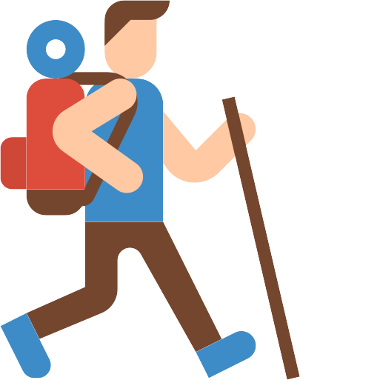 | Take your time! This meeting is a great way to do a different kind of travel, and we encourage you to be adventurous. Hitchwiki (https://hitchwiki.org/) is a Wiki project that provides information on how to hitchhike, where to go, safety tips, etc. If you want to take the bike to the project, we recommend Warmshowers (https://www.warmshowers.org), a couchsurfing project specifically for people on bike tours.
Plane | Vienna has one international airport (VIE). The airport of Bratislava is very close by as well and has bus connections to the Vienna city centre.

Reaching the Venue
The training venue will be in the “4lthangrund” Cultural Centre @Romanogasse
In 2018, 4lthangrund was established with the utopian idea of anchoring art, culture, and social togetherness in the neighbourhood for the long term. Our name takes up the demand “Right to the City”, and since then, we have been operating in the Althangrund area. As a cultural centre, we also offer numerous participating groups a concrete perspective of solidarity-based use of space: office space and communal areas for meetings and events. In January 2026, the cultural centre, with its many groups and activities, moved into two new spaces: the larger one at Romanogasse 28, where we will hold our seminar activities.

Our venue is 4lthangrund in Romanogasse 28, 1200 Vienna, Austria

The venue is easily accessible from Vienna Airport and Vienna Main Station. Please note that taxi costs cannot be reimbursed.

From the Wien Hauptbahnhof (Vienna main train station)
- Buy a single metro ticket (3,00€) at the ticket machine.
- From Hauptbahnhof, take the U1 Metro line (direction Leopoldau) to Praterstern.
- Exit the station and take tram N.5, which departs in front of the station and stops at “Klosterneuburger Straße, Wallensteinstraße”
- Walk 10 minutes to the venue, Romanogasse 28.

From the Wien-Meidling
- Buy a single ticket (€3.00) from a Wiener Linien machine at the station.
- Take Metro line U6 (direction: Floridsdorf) and stop at the station Jägerstrasse (exit Leipziger Strasse).
- From there, walk 5 minutes to Romanogasse 28.

From Vienna International Airport
Train & Tram | Bus
- Buy a single train ticket (5.20€) from Vienna Airport to Wien Handelskai. Take the S7 train to Wien Handelskai – around 25 minutes, with departures every 30 minutes (from 4 am - 0:00)  - From Handelskai take the Metro line U6 direction Sibenhirten and stop at the station Jägerstrasse (exit Leipziger Platz). From there, walk 5 minutes to Romanogasse 28. | - Buy a ticket (€10.50) for the VAL1 Airport Bus to Wien Westbahnhof. Every 30 min until 1 am to Westbahnhof.  - From Westbahnhof, take the U6 Metro line in the direction of Floridsdorf and stop at the Jägerstrasse station (exit Leipziger Platz). From there, walk 5 minutes to Romanogasse 28.

Accommodation

The accommodation will be in the same building as the training venue
Address: Romanogasse 28, 1200 Vienna, Austria
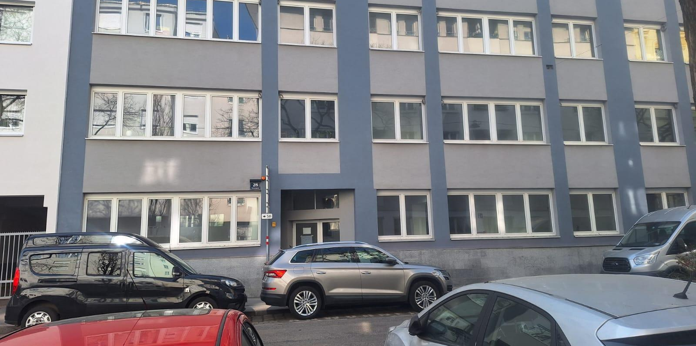
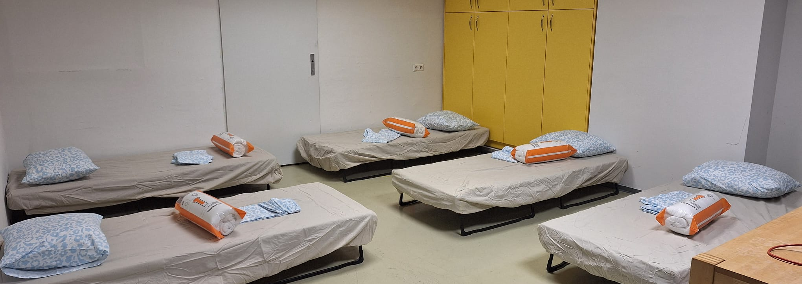
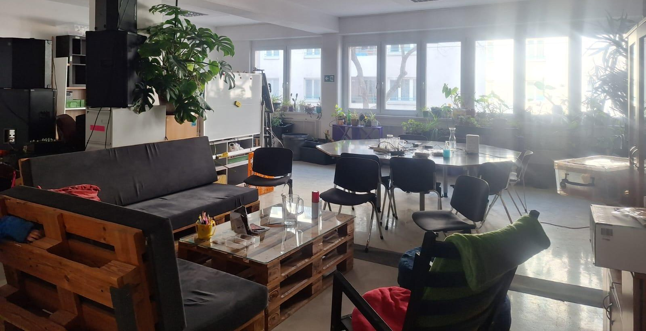
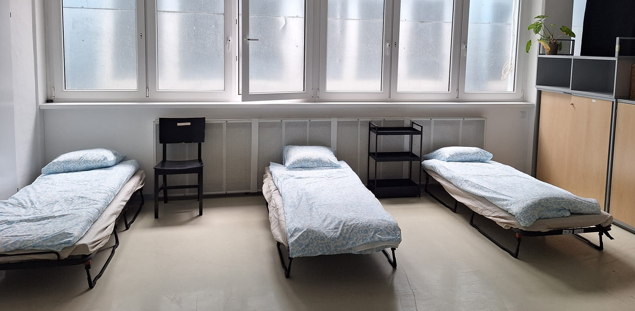

You will be accommodated in shared rooms, 6 participants per room. Make sure to bring earplugs if you are sensitive to noise, indoor slippers and towels. You don’t need to bring your bed sheets.
- There is free internet access at the venue.
- Breakfast, lunch and dinner will be served in the venue. We will provide three vegetarian meals per day, with vegan options available. On the arrival day, the first meal will be dinner.
- The entire building is a non-smoking environment. If you wish to smoke, you must do so outside in designated outdoor areas.
- There are several supermarkets within walking distance.

Bring with you
For the activity, bring with you a physical map of your city.

Please make sure to bring the following personal items:

- Slippers
- Towels
- Your laptop (optional)
- Toiletries
- Rain ponchos (to explore in wet weather)
- Earplugs (if you are sensitive to snoring)
- European Insurance card and passport
- d items from home to share with others during coffee breaks
- Soap and shampoo
- Water bottle
- Warm clothes and/or jumper
- Sunscreen protection
- Working / hiking shoes

Also, in case you have it, bring:
- any tool / publication / methodology connected with the topic of the project;
- a camera
- games to play in the evening

Reimbursement
Reimbursement of travel tickets will be 100% up to the maximum allowed amount, and will be processed only after we receive the receipts and travel documents.

We ask you to book your travel as soon as possible after reading this info pack. Early booking not only helps you secure more affordable tickets but also supports smoother logistical planning for the organisers.
Please keep in mind that only economy or standard class tickets are eligible for reimbursement. Reservations in first or business class will not be covered.

Please follow the following steps for a successful reimbursement of your travel costs:

- Keep all your tickets (trains, subway, bus, plane, Blablacar), invoices, receipts AND boarding passes (for flights) carefully. Make sure the ticket prices are visible and readable! If no price is visible, we cannot process the reimbursement. If you use mobile QR tickets, take screenshots straight away! They will disappear after your trip.
- As soon as you return home, please upload all scanned tickets, invoices, and booking confirmations to the designated Google Drive folder, which will be shared with you. Along with these documents, you’ll also need to complete the reimbursement form that will be sent to you by email.
- Reimbursements will be processed within one month after the end of the activity in Vienna.

If your bank account is in a country outside of the EU / SEPA area, we will try to find a way to avoid banking fees. This may mean receiving the transfer through your sending organisation or an alternative transfer method.

Insurance:
- If you live in the EU, please bring your European Health Insurance Card or your insurance card with you.
- If you are not insured within the EU, please let us know so we can provide you with insurance for the duration of the training.
- If you live outside the EU, we will automatically arrange your insurance through our SCI insurance (unless you have already contracted health insurance in your country to obtain the visa; please inform us if that is the case).
Allergies: If you have any allergies, please bring all necessary medication with you and inform us.

How to apply
At this link, you find the application via Google Forms.

Logistics checklist
- Did you make your travel arrangements? Did you buy your ticket?
- Have you read this infopack thoroughly?
- Did you check and pack the recommended items?

Erasmus+ countries: Albania, Algeria, Armenia, Austria, Azerbaijan, Belarus, Belgium, Bosnia and Herzegovina, Bulgaria, Croatia, Cyprus, Czechia, Denmark, Egypt, Estonia, Finland, France, Georgia, Germany, Greece, Hungary, Iceland, Ireland, Israel, Italy, Jordan, Kosovo, Latvia, Lebanon, Libya, Liechtenstein, Lithuania, Luxembourg, Malta, Moldova, Montenegro, Morocco, Netherlands, North Macedonia, Norway, Palestine, Poland, Portugal, Romania, Serbia, Slovenia, Slovakia, Spain, Syria, Sweden, Tunisia, Türkiye, Territory of Ukraine as recognised by international law.

