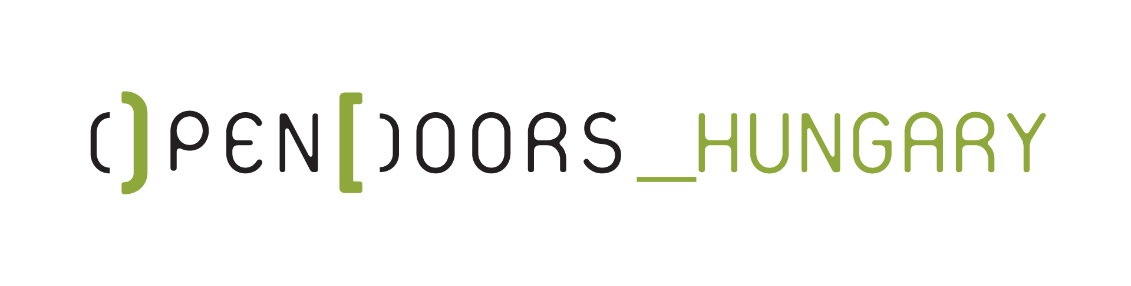

ERASMUS+ PROGRAMME
Key action 1 - Learning Mobility of Individuals

From ME to WE - Designing Community

Dates of Youth Exchange: 18th – 25th August 2019
(18th August: arrival day; 25th August: departure day)
Hungary (location TBA)

Please return this form to: inclusione@sci-italia.it

ORGANIZATION: SCI-Italia

FIRST NAME:

SURNAME:

GENDER: □ Male □ Female

DATE OF BIRTH:

PLACE OF BIRTH (town, country):

RESIDENCE ADDRESS (street, town, country):

TELEPHONE:

E-MAIL:

EMERGENCY CONTACT:

Name: Surname: Telephone:

SPECIAL NEEDS (OR HEALTH REMARKS):

PAST EXPERIENCES:
- with volunteering
- with refugees and migrants
- with creativity

WHAT IS YOUR MOTIVATION TO TAKE PART IN THIS PROJECT?:

WHAT ARE YOUR EXPECTATIONS OF THE PROJECT?:

