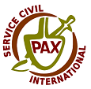
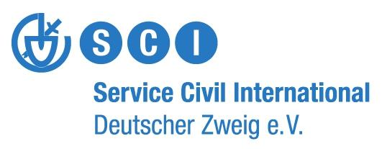
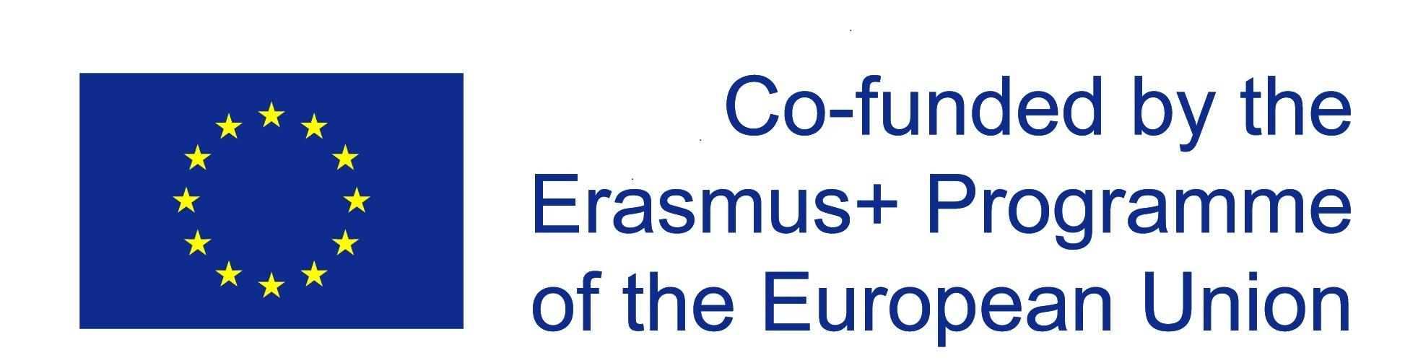
Call for applications

“A daily plate of peace and non-violence:
How our values should and can be represented in our food consumption "
“Sharing Our Food” 10. – 17.03.2019 Rome

Background of the project
“First we eat, then we do everything else” M.F.K. Fisher
Eating is one of the most important things you do and for sure it’s also important in workcamps and youth exchanges. Cooking and Eating can bring a group together, it can show you how similar and how different people are, it helps you to get satisfied and happy. Many values can be represented in our food consumption - and food is connected to climate change, to social injustice, to capitalism and exploitation.

As SCI from its beginning almost 100 years ago had worked for the goal of a culture of peace and non-violence also food consumption and its impact on social inequalities and a sustainable planet need to be addressed to follow a holistic approach. So with “A daily plate of peace and non-violence: How values should and can be represented in our food consumption” we want to strengthen a sustainable and just food consumption on SCI projects and in the environment of all participants. The project is going to raise awareness and promote critical reflexion of current practices of food consumption in youth exchanges, seminars/ trainings and workcamps/ short term volunteer projects.

The first part of the project already took place. We had a training in November on the problems and challenges of our global food system in Witzenhausen, Germany. There we also talked about the topics connection to the SCI and started to develop a structure for our outcome, which will be a toolkit and a cookbook. Now we’re going to meet again in Rome, to have some more Input and to finish a first draft of the publications.
We will be 23 participants from different European countries (Austria, Belgium, Croatia, Germany, Hungary, Italy, Ireland, Netherlands, Poland and Spain). Since until now we are only a relatively small group, which already met in November we are in need of new activists to join our project for the coming seminar! We are pretty much looking forward to welcome you in Rome. As we had some basic Input in the Witzenhausen Training it might be more comfortable for you and the group if you have some knowledge about at least one aspect of the topic, such as consequences of food production on climate crisis or social justice, fair and ecological food production, plant based food, food waste, nutritionist..., so that we can start from an similar page in Rome.

Outcome
We’re going to create together
- a cookbook and guidelines on food consumptions in camps, trainings, seminars, meeting, workshops and youth exchanges as well as
- a toolkit with non-formal education (NFE) methods for workshops and activities on the topic of a sustainable food consumption.
We believe that both publications will be necessary to improve the ecological and social impact of the projects because the cookbook will give tools for such a change, but change will only be possible if the participants of a project are aware of why they are doing things a certain way. For this reason, also educational tools are necessary to create an impact during and beyond the SCI projects.
Timeline of the Project
The overall project consists of three encounters and local activities between these:
- „Preparing our plates”- training (already past)
18.-25.11.2018 in Witzenhausen (near Göttingen), Germany
Contents: In our first meeting we had a training on the following topics:
- local and global impact of food on resources, climate change, animal rights and social justice
- food and its connection to economic growth
- Power of the consumer and which actors can change things how
- how can a conscious food consumption look like
- alternative and sustainable practices of food consumption
- a balanced localized plant-based diet
- ideas and inspirations for structure and content of Toolkit and Cookbok

- Research and Reflection time; Skype-Meeting January/February 2019
Before we meet in Rome every participant should do some research on relevant organizations, networks, movements, NFE methods, publications and recipes. We did a plan of action in Witzenhausen, where we divided tasks, but also new participants should already do some research (such as recipes). We will have one skype-meeting in the end of January / beginning of February where we would like to meet all Rome participants to talk about that.
- “Sharing our food”- seminar
10.-17.03.2019 in Rome, Italy
Content: After having a short revision on what we did in Witzenhausen, we’re going to exchange best practices, share methods and interesting things that were discovered and developed after the Witzenhausen training. We will also have some sessions focusing on workers/human rights and social justice in the food system an discovering concepts like food sovereignty and its connection to peace work.
One big part of the seminar will be to work actively on the publications, go deeper on NFE and create our Utopia of a non-violent and sustainable food production and consumption.
About the venue: The seminar will take place at La Città dell'Utopia, which is run by SCI Italia. It's a
lab of active citizenship as well as an “open sheltering center” where refugees and asylum seekers
can interact with local citizens. It has a hostel and an organic garden as well.
If you liked the project and you are still motivated to be part of it we are really looking forward to welcome you to the following activities of the project as well:
- Bringing it into action
After the seminar in Rome it’s time to bring the studied topics and developed methods into action. You will support your sending organisations in their camp coordinator trainings and support the coordinators in implementing activities on a sustainable and social just food consumption in their volunteer projects.
- “Evaluation, dissemination and follow-up”- seminar
24.- 29.09.2019 around Vienna, Austria
Content: In the final meeting the we will evaluate your activities after the Rome seminar and the overall project. We’re going to create a greater visibility for the project and its outcomes. We will work on the guidelines for food consumption on volunteer projects for strengthening and mainstreaming food sustainability within SCI activities. There will also be the launch of the final cookbook.
Methods: We’re going to use a broad variety of non-formal education methods, such as worldcafe,
snowball discussions, research, silent exhibition, simulation games, theatre, visual harvesting, arts,
energizers, role games, teambuilding games and more. There will also be projects visits to local initiatives.
Participants Profile - Rome seminar
All participants selected for this project must meet the following criteria:
- as the first training already past: having some basic knowledge about the impacts of food to the environment, climate crisis, social justice and animal rights; or willing to spend some time preparing with materials provided by the trainers
- be 18 years old or older
- be able to come to the seminar by train or bus, due to the high impact of flying on climate crisis (If you think that there is no other way than coming by plane, please contact the prep-team)
- be able to work in English language
- be interested in the project topics and have strong motivation to act as multiplier
- have a strong motivation to work on the toolkit and/or the cookbook
- commit to implement the learned knowledge and skills in practice back home;
- commit to send a report of the seminar to your sending organisation;
- be motivated to work with people from different backgrounds
Please note that there will be a few opportunities to visit Rome, but that this is not a “getting to know the region” project. On some days the seminar also foresees evening sessions.
Applications should be sent to your own SCI branch, which will each select their own two participants and then notify SCI-D. All those accepted will later receive a detailed info-sheet. Deadline for applying is 25.01.2018

Financial and practical conditions of participation:
All essential costs of the programme in Rome (including food, accommodation and training) will be covered by SCI-D. The food will be plant based, in line with the project’s objectives.

International travel costs will be reimbursed 100% up to the following maximums per person:
Poland, Germany, Ireland, Greece, Hungary, Republic of Macedonia, Netherlands, Spain: 275 €
Italy: 80 €

Contact
If you have any questions regarding the project, don't hesitate to contact us: val_weidinger@yahoo.com
You should send your application to:

We are looking forward to your application :-)
The coordinating team Steffi, Simon and Valerie

See Application form below

“A daily plate of peace and non-violence:
How our values should and can be represented in our food consumption "
10. – 17.03.2019 Rome

Application form

Please send your application to your sending organisation:

Surname
(as written in passport)
First name
Birth date
Nationality
Personal Address
Phone Number
Email
Emergency person
Contact Emergency person
(phone / email)
Special food needs?
(Allergies, intolerances, diet, etc.)
Passport Number
(if visa required)
English skills | Very good | Good | Poor
Speaking
Writing
Understanding
Name of your sending organisation

------- Please continue on page 2 --------
For the following questions, please write briefly your most important arguments. This will help us to design the seminar according to your and the whole group‘s needs.
Experiences
How long have you been involved in your organisation and what are your roles?
Do you have knowledge about food and it’s connection to climate crisis, social justice and animal rights? Please specify shortly
Do you have previous experience in peace work and ecological education? Have you been involved in activities or organisations focused on food education or connected to ecology? If so, what was your role?
Motivation and expectations
What are the main reasons you wish to participate and what are your expectations for the seminar?
How do you want to use the acquired tools and knowledge in your organisation in the future?
Do you have an idea for a method or session that you could share in Rome?
Please give details, if possible: time needed, number of participants, kind of activity, topic
Further information
Do you have any special needs or requirements (e.g. disability, etc.)? Please specify:
You can state here any other information you would like to share.

Declaration and commitment
I am fully aware that my participation in this activity is an investment of the organisers (in terms of logistic, finances, time and personal involvement of all people engaged) in my personal learning experience.

- I declare that the information provided in my application is true and I commit myself to participate actively in the whole duration of the project.
- I promise to share the experiences gained in the course with other fellows from my sending organisation and/ or other persons in my professional/ private / volunteer environment;
- I promise to implement learned experience at the local level;
- I commit to attending the training in full, with no late arrival and early departure or leaving sessions;

I read and understood the text of the declaration.

Date: Signature*:

*can be a digital signature

